RAYAT SHIKSHAN SANSTHA’S


SADGURU GADAGE MAHARAJ COLLEGE KARAD.
A
Project Report
On
“Detailed Exploratory Data Analysis With Python”
Submitted to
SHIVAJI UNIVERSITY, KOLHAPUR
Through
DEPARTMENT OF COMPUTER SCIENCE
SADGURU GADAGE MAHARAJ
COLLEGE KARAD.
(AN EMPOWERED AUTONOMUS COLLEGE)
IN PARTIAL FULFILMENT OF THE DEGREE
Bachelor of Computer Science (Optional)
Part – III Semester-VI
Submitted By
Miss.Sanika Nathuram Ghadge
Miss.Sakshi Sanjay Mohite
Miss.Pallavi Sanjay Ghadge
Miss.Nikita Prakash Todkar
Under The Guidance of
Miss. Thorawde A.S
RAYAT SHIKSHAN SANSTHA’S

SADGURU GADAGE MAHARAJ COLLEGE KARAD.

Certificate

This is certify that Miss. Sanika Nathuram Ghadge, Miss. Sakshi Sanjay Mohite, Miss. Pallavi Sanjay Ghadge & Miss. Nikita Prakash Todkar have satisfactorily completed the Major project entitled as “Detailed Exploratory Data Analysis with Python.” in the partial Fulfilment of B.Sc. Computer Science(Optional) Part-III Sem-VI during the academic year 2025-26.

Place : Karad
Date :

Guide Examiner Head of Deparment

ACKNOWLEGMENT

We express our sincere thanks to Hon. Principal Dr C. J. Khilare of SGM college, karad for providing us with the opportunity to undergo On-the-Job Training (OJT).
We are also thankful to Mrs. Pawar B. A (HOD of B.sc cs Department) thanks to my internal guide for continuous guidance, encouragement, and valuable suggestions throughout the training period. We would like to thank to other teaching and nonteaching staff members of Computer Science Department for their valuable suggestions during training period.
I also extend my heartfelt thanks to the management and staff of plexus skills for their support, cooperation, and for sharing their knowledge and experience.
At last but not least, we are very much thankful to our parent and friends for co-operation to successfully complete this on job training program.

Miss.Sanika Nathuram Ghadge
Miss.Sakshi Sanjay Mohite
Miss.Pallavi Sanjay Ghadge
Miss.Nikita Prakash Todkar

Place:karad
Date:

INDEX

Sr no | Content Name
1 | Company Profile:  - History  - Background  - Orgnizational Structure  - Services
2 | Training program details:  - Objective  - Schedule  - Area of Training
3 | Weekly/Daily reports:  - Learning each week
4 | Personal evaluation of the training program:  - Significant achievements and skills learned  - Experience with personal(company)  - Output Screens
5 | Appendices:  - Copy of certificate

Company profile


Plexuxs skills is an organization that specializes in Data Analytics,Data Science, Artificial Intelligence and Full Stack Development. The company was established in 2022 with the objective of providing Job ready programs including python, Machine Learning, Data Analystics and SQL, featuring 100% placement support, internships and expert Training for freshers. Over the years, it has grown into a reputed organization known for its commitment to quality and innovation.

Vision and Mission

- Vision:
To deliver reliable and innovative solutions in the field of Data Analysis, Data Science and Full stack development.

- Mission:
To continuously improve services through technology, teamwork, and customer satisfaction.

Organizational structure

The organization consists of departments such as Management, Development/Operations, Quality Assurance, and Support Services, all working together to achieve organizational goals. The company is structured into Executive Leadership, internship and Data Science.

Services offered

- Data Science
- Artificial intelligence
- Full stack development
- Machine Learning
- System analysis and design
- Data handling and reporting
- Technical support and maintenance

Training program details

Objectives:
General objectives
- To gain practical exposure to real-world working environments.
- To understand professional ethics and teamwork in an organization.
Specific objectives:
- To apply theoretical knowledge in practical scenarios.
- To develop technical and analytical skills.
- To understand project development life cycles.

Training Shedule:
The training was conducted over a period of 5 weeks. Each week focused on learning new concepts, tools, and practical implementation under supervision.

Area of Training:
- Requirement analysis and feasibility study
- Hardware and software requirements
- Project planning and execution
- Implementation and testing

Weekly Training Report

Week 1:
- Activities performed
- Company orientation
- Introduction to tools
- Learning outcome
Understanding work culture and basic tools.

Week 2:
- Activities performed
- Requirement analysis of project
- Data collection for project
- Learning outcome
Learned requirement gathering techniques.

Week 3:
- Activities performed
- Design project
- Development of project module
- Learning outcome
Improved technical and logical skills.

Week 4:
- Activities performed
- Testing
- Debugging
- Learning outcome
Learned error handling and optimization.

Week 5:
- Activities performed
- Final implementation
- Ppt presentation
- Learning outcome
Understood project deployment and reporting

All about on Job Training:
We worked on collecting, cleaning and analyzing datasets to support data-driven decision making. We performed data preprocessing tasks such as handling missing values, removing duplicates and formatting data using python. This on job training helped me strengthen my analytical skills, improve my understanding of real-world data problems and gain hands-on experience in data analysis workflow.

Personal evaluation of the training program

Skills and Achievements
During the training period, I gained both technical and soft skills. Technical skills include hands-on experience with programming, data analysis, and system implementation. Soft skills such as communication, teamwork, time management, and problem-solving were also significantly enhanced.

Experience with company personal
The staff and mentors at plexus skills were highly supportive and cooperative. They provided guidance whenever required and encouraged learning through practical exposure.

Strengths of the program
One of the strongest aspects of the program was the balance between theory and hands-on practice. The exercises and examples made complex concepts easier to understand, and the real-world scenarios helped me see how python can be applied in practical can be applied in practical situations.

Trainer / Instruction Quality
The instructor explained concepts clearly and encouraged questions and discussions. Doubts were addressed promptly, which made the learning environment and engaging.

Personal growth
This training improved my problem-solving skills and logical thinking. I now feel more confident exploring python-based projects and continuing my learning independently.

Project output
The project developed during the training successfully met the defined objectives. Output screens and results demonstrate the effective implementation of concepts learned during the training.

Output Screens

1)Loading libraries
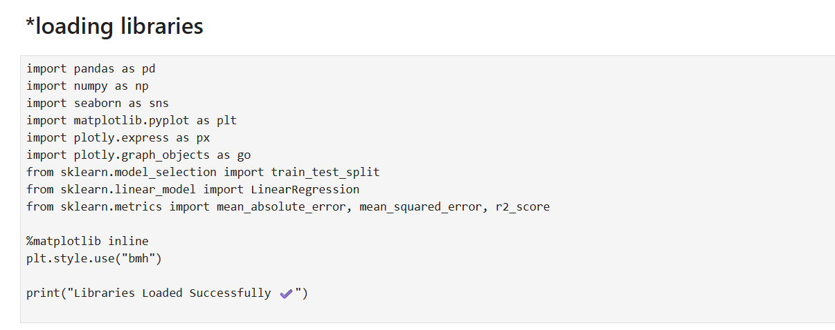

2)Loading Dataset
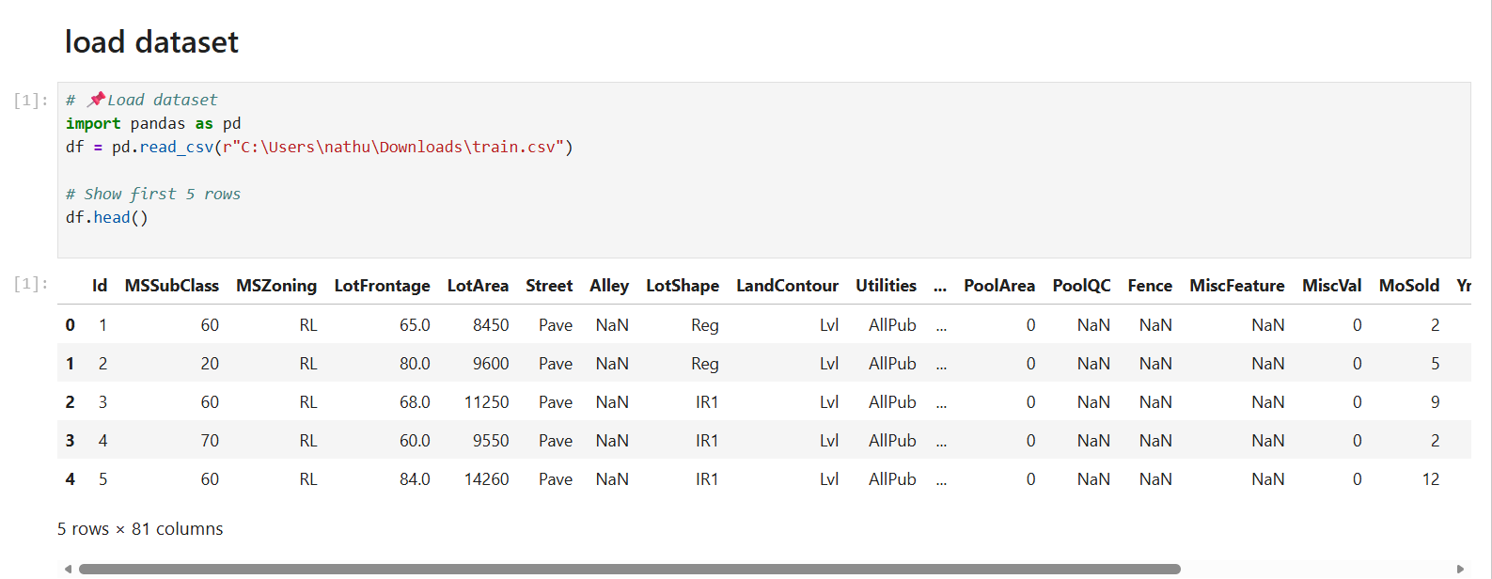

3)Identify Numerical and Catogorial Features
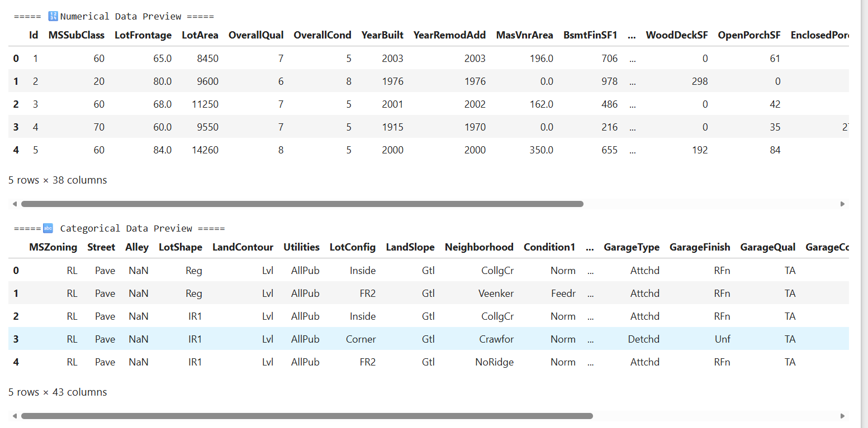

4)Missing values analysis

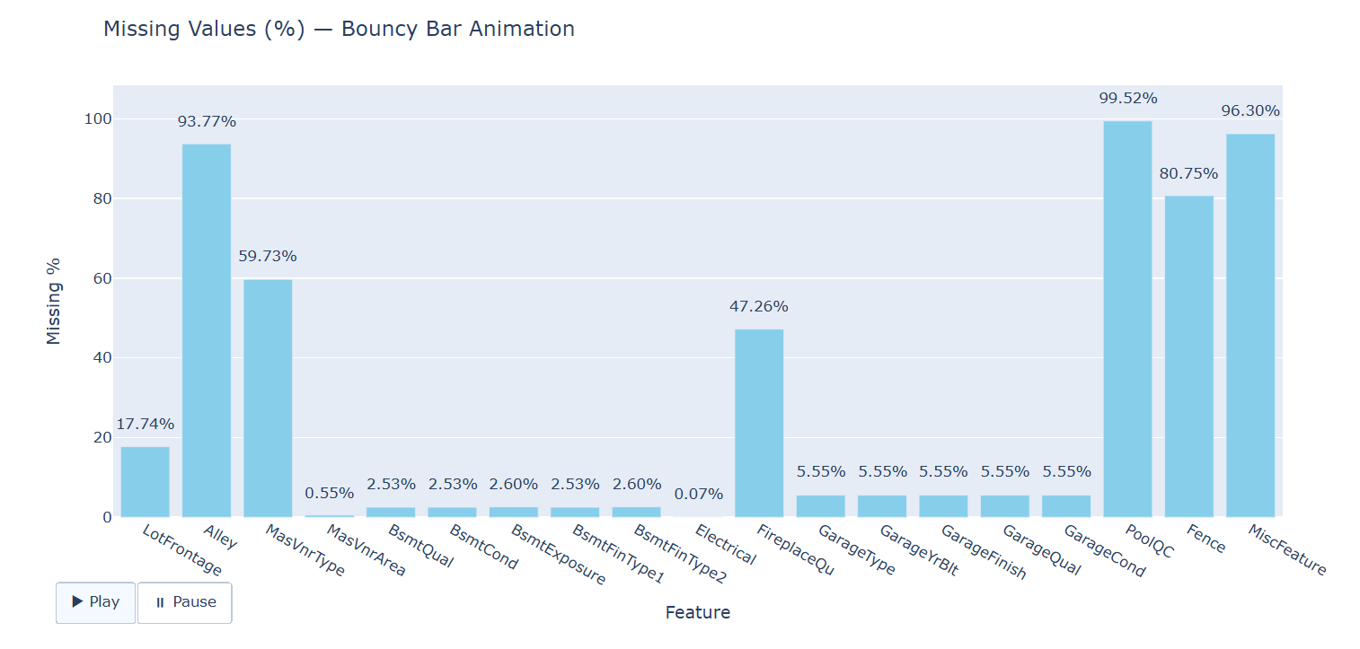
5)Machine Learning concepts
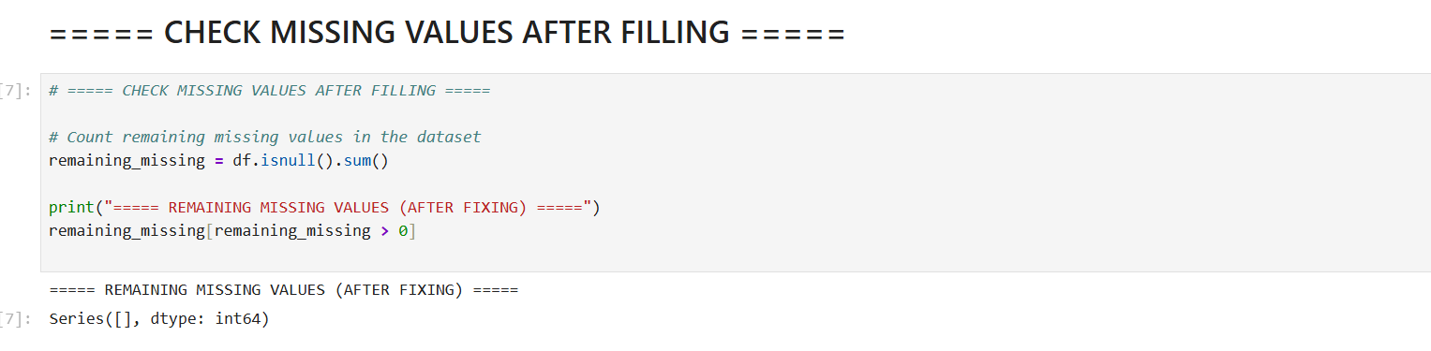
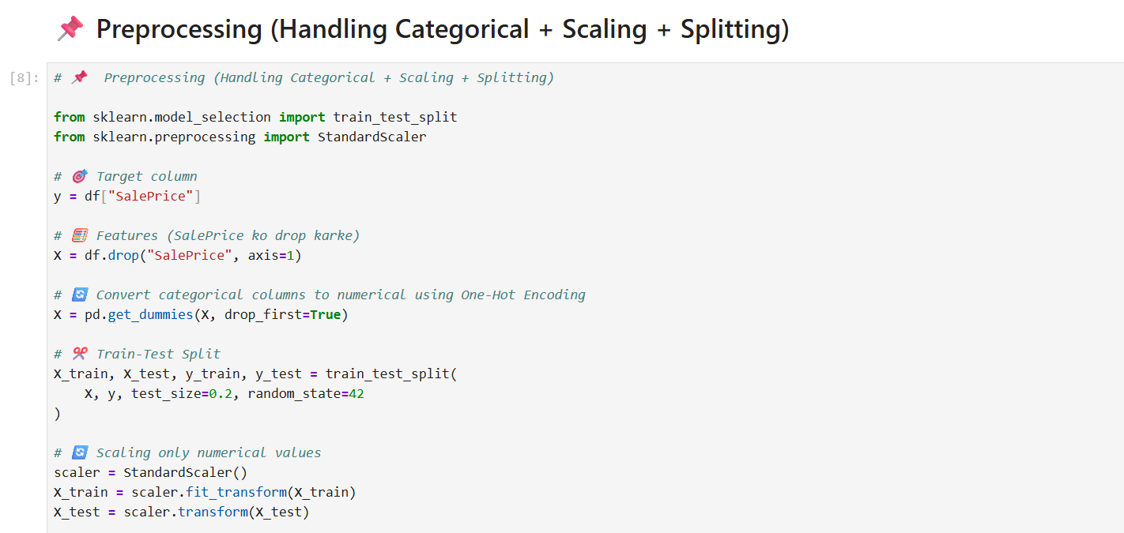

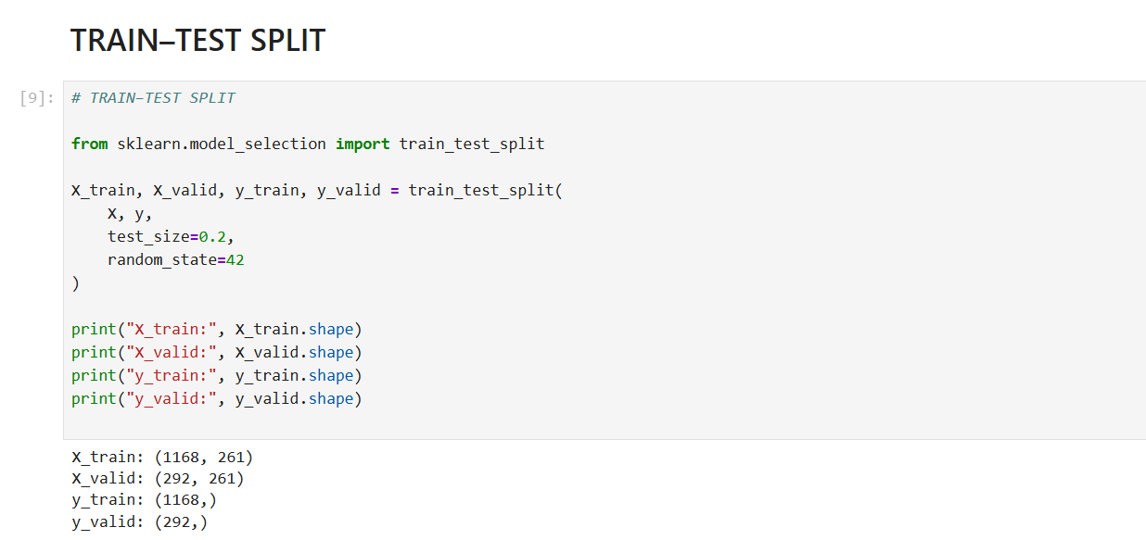

6)Pie Chart

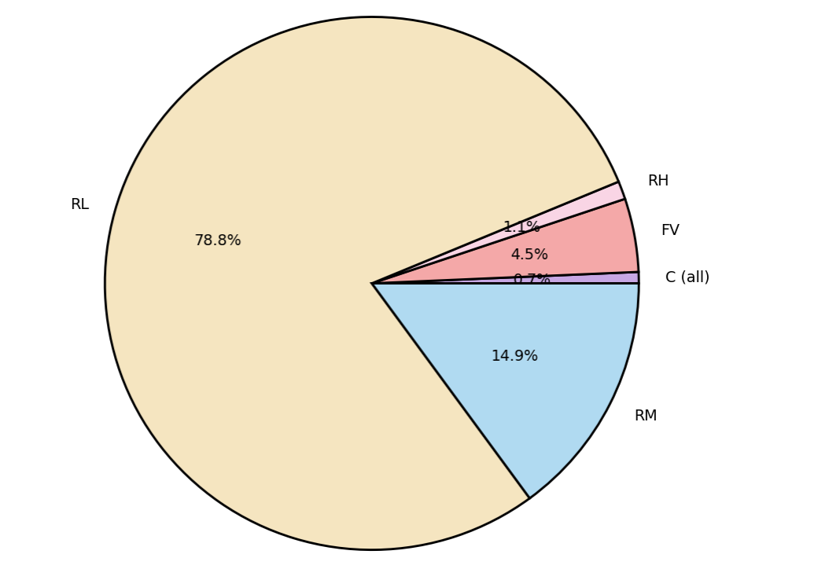
7)Bar Chart

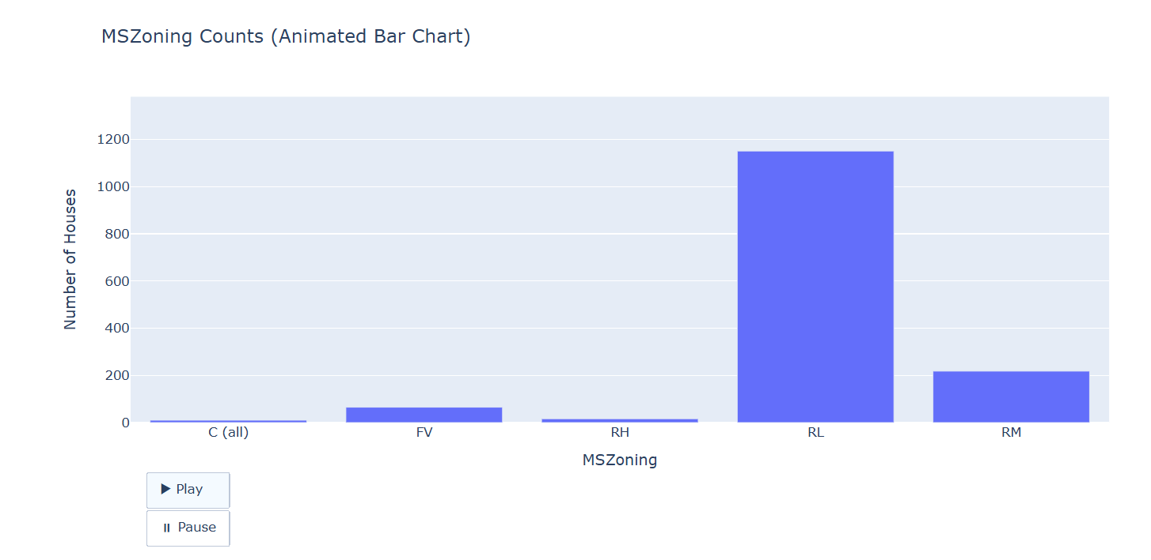

8)Animated Histogram
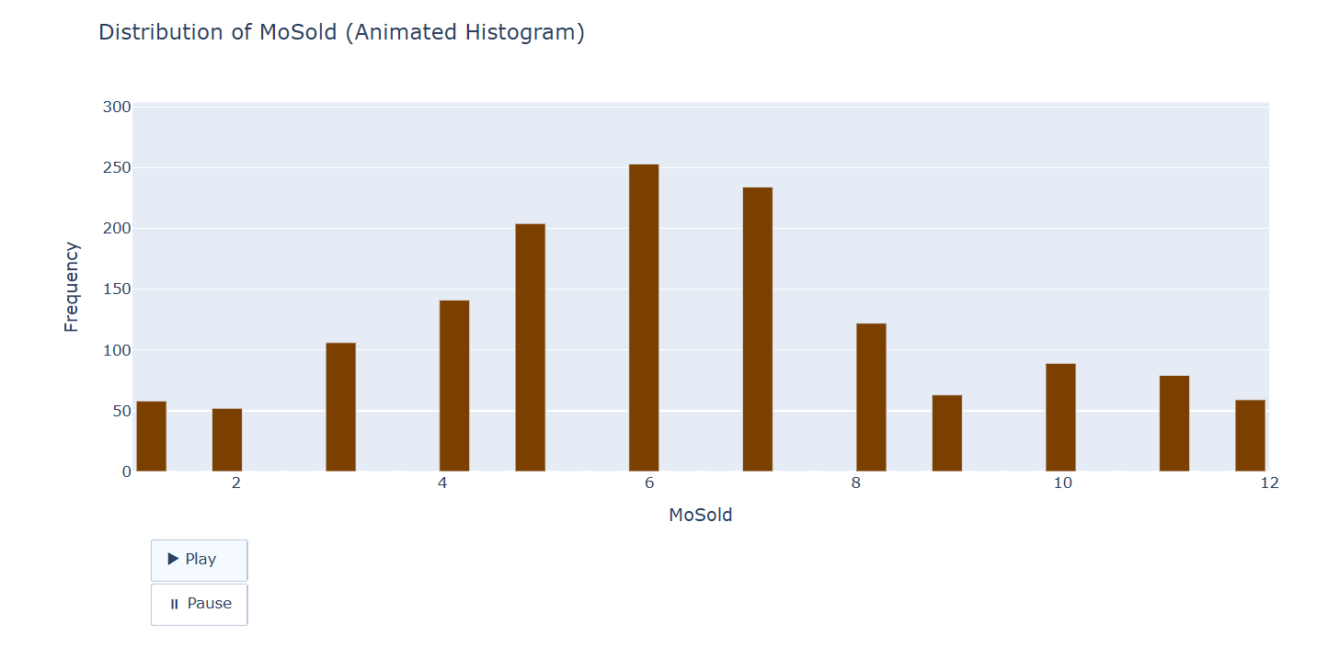
9)Model Training and Evalution

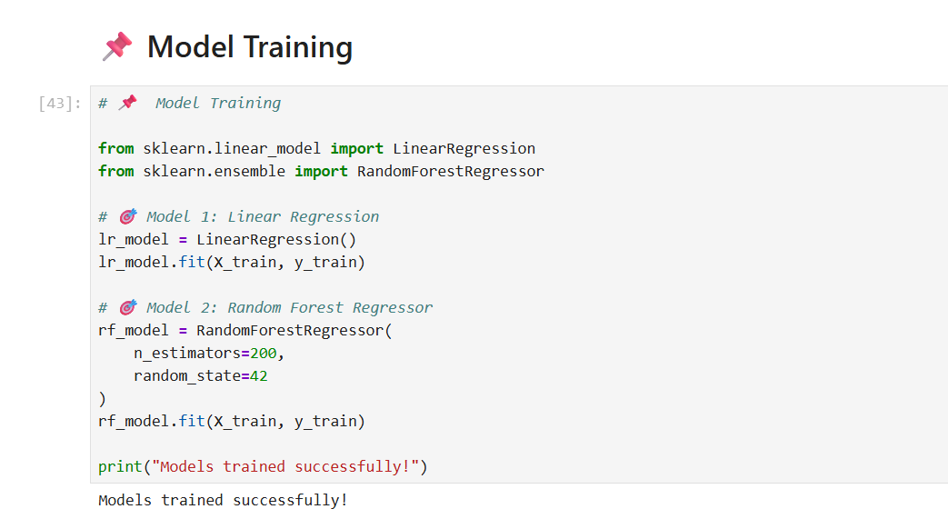
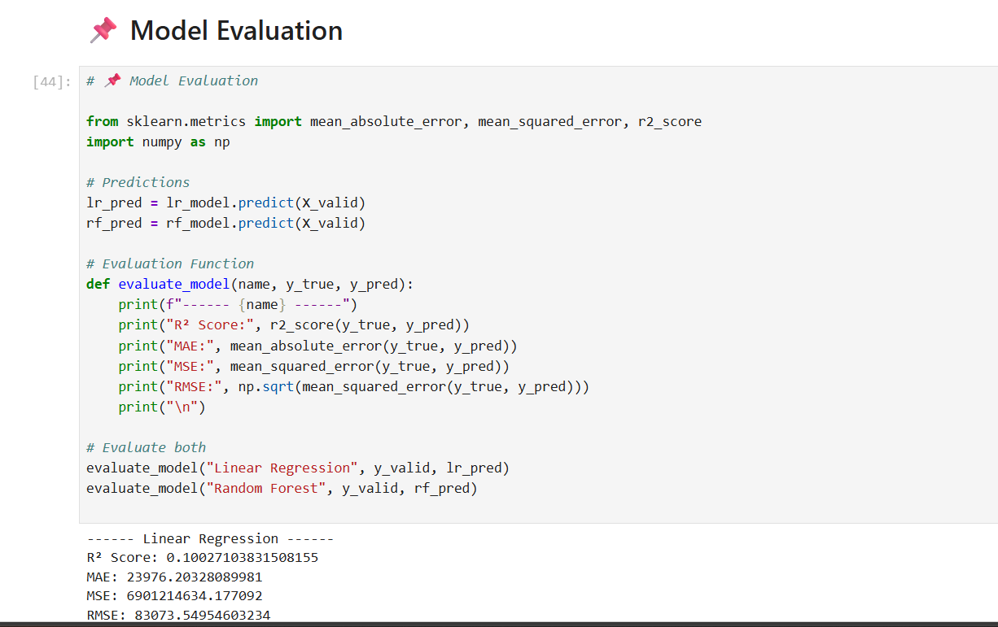

10)Heatmap
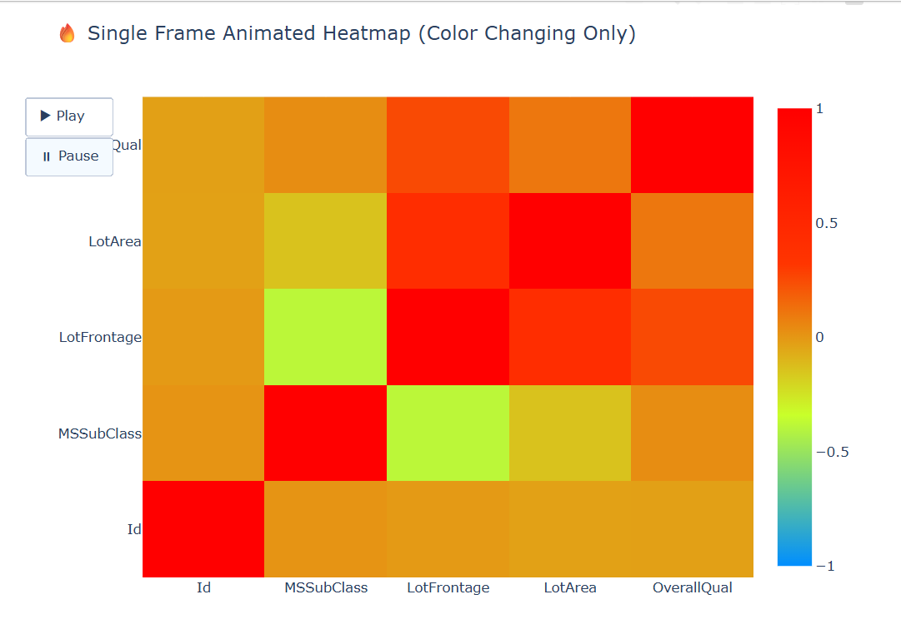

11)Pricemeter

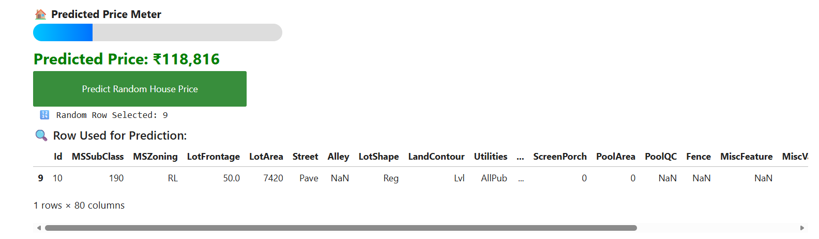

Appendices

